1. Based On Classes and Object

Create Employee class with following Properties

Int id;

String fname

String lname

String email

Access all the properties in other class and main method and display

1. Based On Array
2. Access all Element of Array for For and ForEach loop
3. Initialize array size by taking input form user
4. Find sum of All element of Array
5. Find Avg of all Element of Array
6. Based on Array

Count repeating String

String s[]={“abc”,”dce”,xyz”,”abc”,”xyz”};

Output=> Abc-2, dce-1, xyz-2

1. Store Employee Object in Array and display
2. Based on Array and Exception , toString()

Having 2 user Admin and Normal user (Object will create before showing ui, login page/asking to enter cred)

1. Admin can do any operation
2. Normal User can just view any Employee Details
3. Program start with showing login ui, asking username and Password
4. User will be authenticated based on permission ui will be shown below option, user can enter 1 (not taking add or delete) he will choose option (for now no need to change)
5. If Admin
6. Add Employee
7. Update Employee(based on Id, ID is Primary should be changed)
8. Delete Employee(based on Id)
9. View Employee(based on Id)
10. If Normal user
11. View Employee (based on Id)
12. View All Employee details

Handle Exception

Throw Custom Exception if Cred Enter are wrong an Terminate the program

1. Create Thread in 2 way, sleep the current running thread for 2 sec , change the thread name, print the current Running Thread name
2. Add Employees to Collection and work with some method on like add(), addAll(), remove(), removeAll(), contains(), size(), clear() etc
3. List Of Employees (No Duplicate allowed), and list can sort

1. Based on id

2.baed on name

1. Employees Management functionality will be achieved by using Collection FrameWork
2. Employees Management functionality will be achieved by using jdbc (DataBase)
3. Employees Management functionality with Web Application
   1. Login page with error message
   2. Should have register button on login page
   3. Upon click on register button should display Register page with following option
      1. ID
      2. Name
      3. Email
      4. Password
      5. Salary
      6. Permission (disabled or hidden)by default it should be Normal user not admin (cm will be used to give admin persmission)
      7. After successful Registeration redirect to login page with success message displayed on login page
      8. Successful login should display user email and list of employe details in table with each ow having button as screen shot
      9. With Admin user

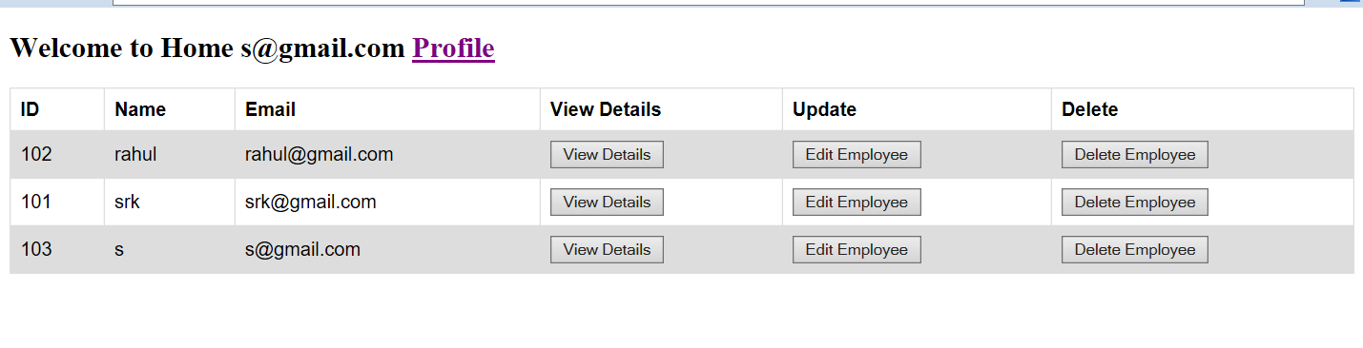

With Normal User

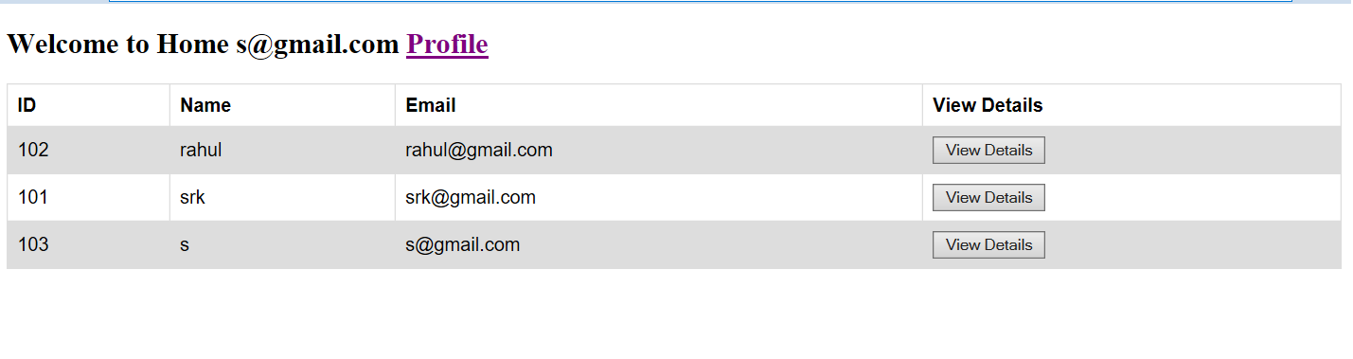

After clicking on edit edit screen should be displayed disable id all other fields are editable

For view button don’t show password and not update option

Log out button which will kill the session and redirect to login page